TP5 LOUAIFI AZOUAOU 202031044812 G3

alter session set "_ORACLE_SCRIPT"=true;

create user USER1 identified by USER1;

create user USER2 identified by USER2;

grant all privileges to USER1_1;

create table employe(

    NUmE INTEGER,

    NomE varchar(30),

    fontion varchar(100),

    codeS varchar(3) ,

    constraint PK_EMPLOYE primary key (NUmE)

);

create table Service(

    codeS VARCHAR(3) ,

    Noms VARCHAR(20),

    chef_S INTEGER,

    constraint PK_SERVICE primary key (codeS)

);

create table operation(

    codeop varchar(5)  constraint PK_operation primary key ,

    duree number(2),

    chef INTEGER ,

    datedeb date,

    budget number(8,2),

    codeS varchar(3)

);

create table membre(

    numE INTEGER,

    codeop varchar(5),

    constraint PK_membre primary key (codeop, numE)

);

insert into operation values ('OP001', '48', '13', '01/10/2018', 180000.00, 'S01');

insert into operation values ('OP002', '48', '5', '10/09/2016', 100000.00, 'S04');

insert into operation values ('OP003', '36', '14', '05/01/2018', 200000.00, 'S02');

insert into operation values ('OP004', '30', '13', '10/09/2017', 270000.00, 'S01');

insert into operation values ('OP005', '30', '8', '01/03/2018', 100000.00, 'S05');

insert into operation values ('OP006', '36', '5', '10/09/2019', 300000.00, 'S04');

insert into operation values ('OP007', '36', '13', '10/05/2018', 200000.00, 'S01');

insert into operation values ('OP008', '36', '4', '10/01/2020', 100000.00, 'S05');

insert into operation values ('OP009', '30', '13', '10/09/2020', 150000.00, 'S01');

insert into Service values ('S01', 'informatique', '13');

insert into Service values ('S02', 'panification', '14');

insert into Service values ('S03', 'comptabilité', '3');

insert into Service values  ('S04', 'construction', '5');

insert into Service values ('S05', 'technique', '8');

insert into Service values ('S06', 'statistique', '11');

insert into employe values (1, 'belkadi', 'ingénieur d"état en informatique','S01');

insert into employe values (2, 'benslimane', 'technicien','S04');

insert into employe values (3, 'zerguine', 'chef comtable','S03');

insert into employe values (4, 'naili', 'ingénieur p.c','S05');

insert into employe values (5, 'touahri', 'architecte ','S04');

insert into employe values (6, 'mehdjoubi', 'comptable ','S03');

insert into employe values (7, 'messaoude', 'ingénieur d"application en informatique','S01');

insert into employe values (8, 'ghrissi', 'ingénieur  g.c','S05');

insert into employe values (9, 'otmani', 'comptable','S06');

insert into employe values (10, 'benyahia', 'technicien ','S05');

insert into employe values (11, 'kadi', 'master en satatistique','S06');

insert into employe values (12, 'sissaoui', 'agent administratif','S02');

insert into employe values (13, 'benaissa', 'ingénieur d"état en informatique','S01');

insert into employe values (14, 'achour', 'administrateur principale','S02');

insert into Membre values (13, 'OP001');

insert into Membre values (7, 'OP001');

insert into Membre values (1, 'OP001');

insert into Membre values (5, 'OP002');

insert into Membre values (2, 'OP002');

 grant create session to USER2;

 grant create table to USER2;

conn USER2/USER2;

conn USER1/USER1;

grant references  on employe to USER2;

grant references  on operation to USER2;

select* from USER1.employe;

grant select on employe to USER2;

grant update (fontion) on employe to USER2;

select* from USER1.employe;

update user1.employe set fontion='technicien superieur' where numE=2;

revoke update  on employe from USER2;

update user1.employe set fontion='technicien superieur' where numE=3;

grant select on chef_sevice to USER2;

select  nomChef from user1.chef_sevice where Noms='technique';

alter session set "_ORACLE_SCRIPT"=true;

create role agent;

grant select on service to agent;

grant update on operation to agent;

grant agent to USER2;

select * from user1.service;

update USER1.operation set datedeb='05-10-2021' where codeOP='OP003';

grant select on operation to agent;

 select * from user1.operation;

 select nome from user1.employe where numE in(select numE from membre);

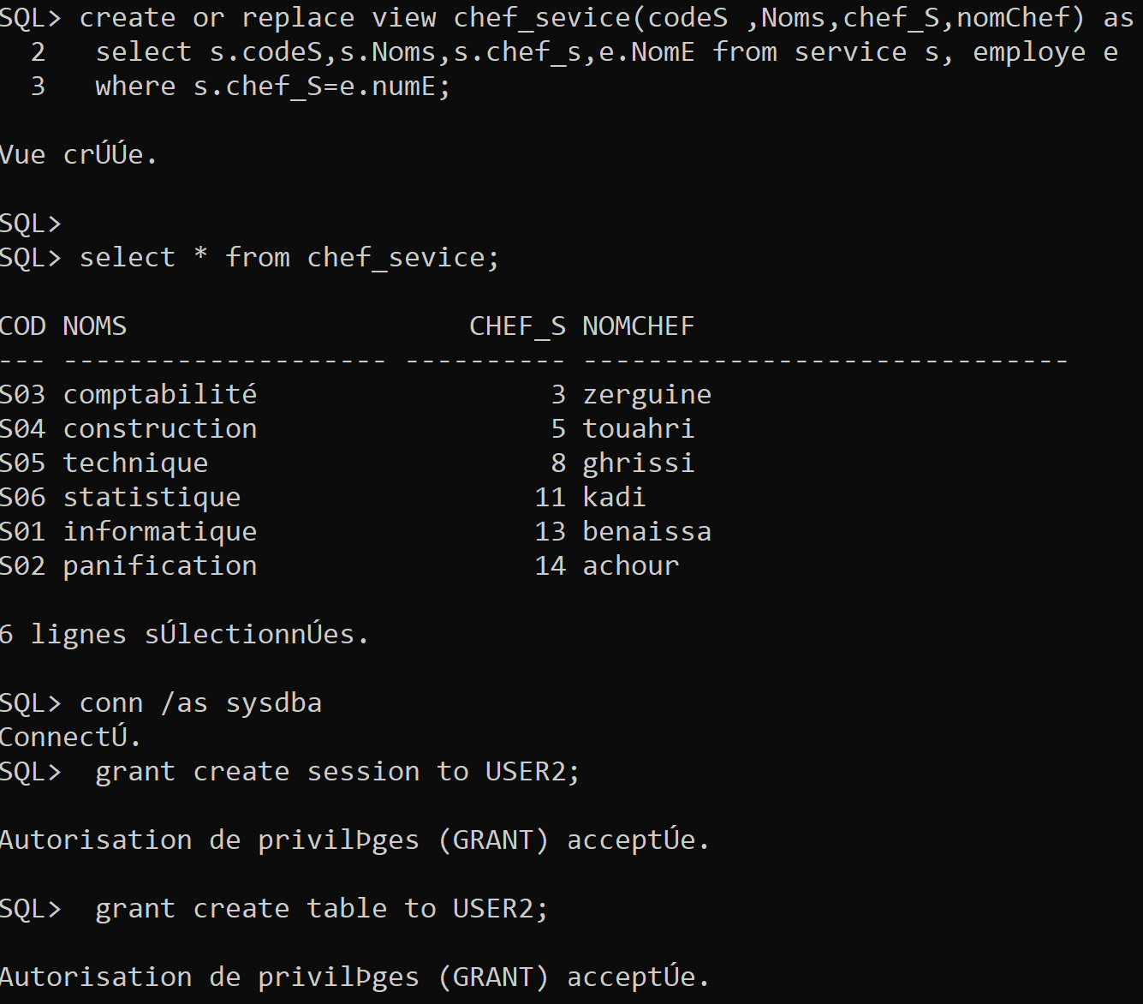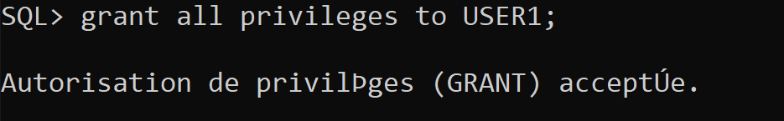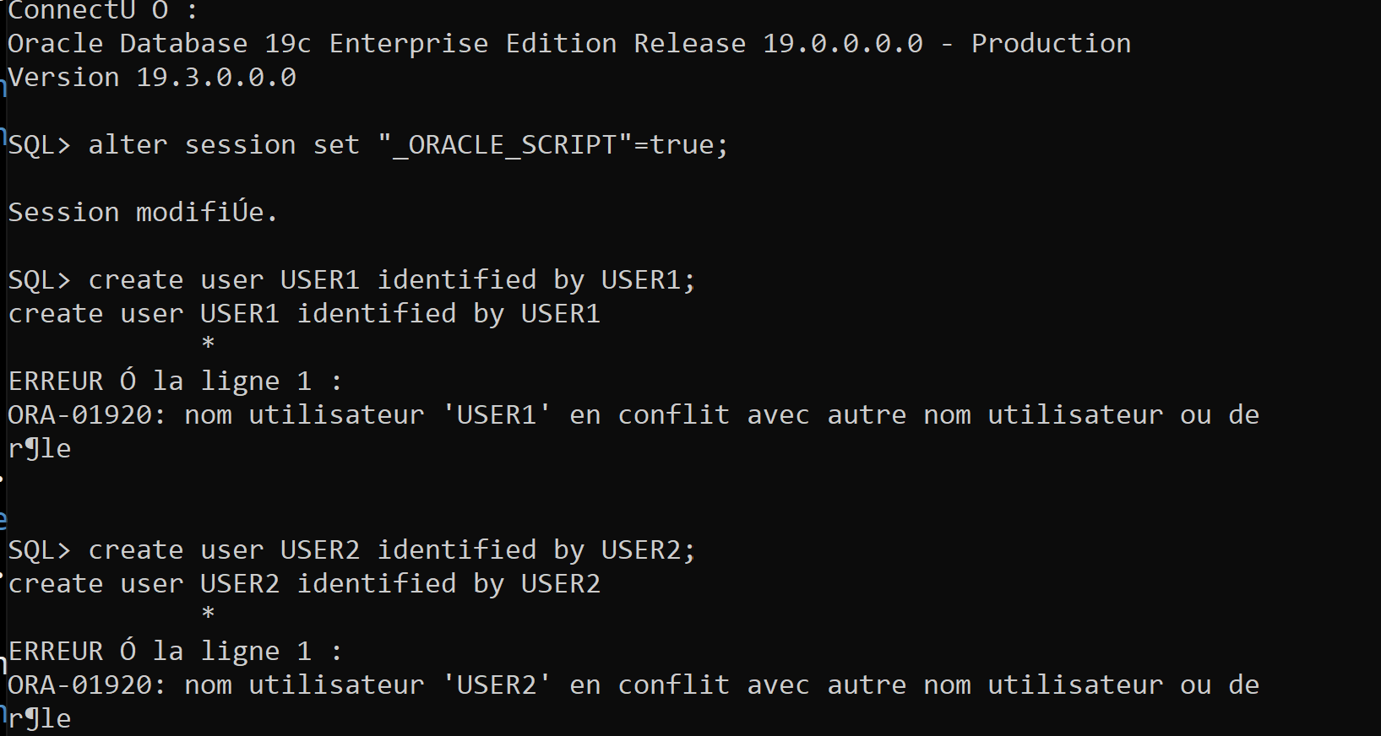EXECUTION :

